# CS 255 System Design Document Template

## UML Diagrams

### UML Use Case Diagram

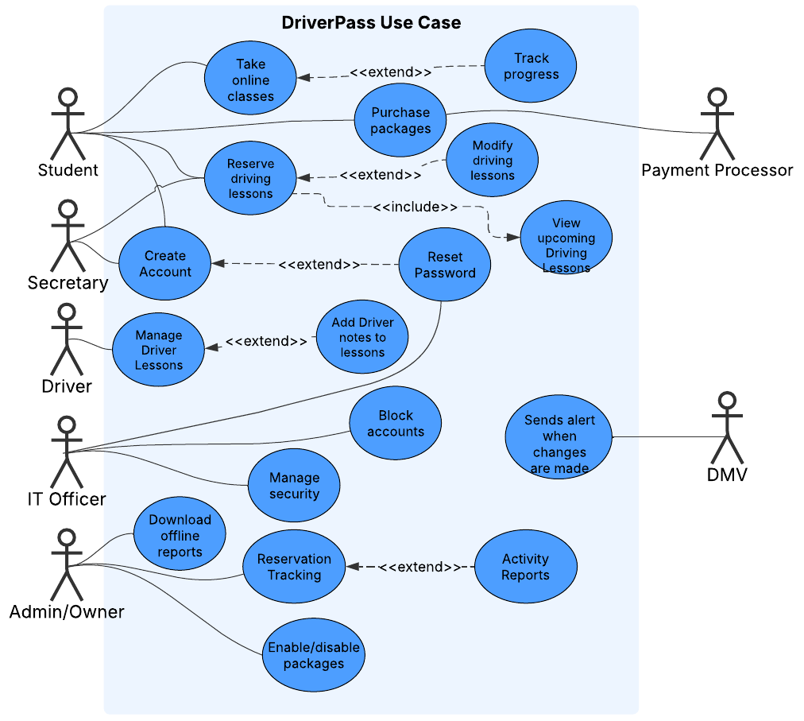

### UML Activity Diagrams

### UML Sequence Diagram

### UML Class Diagram

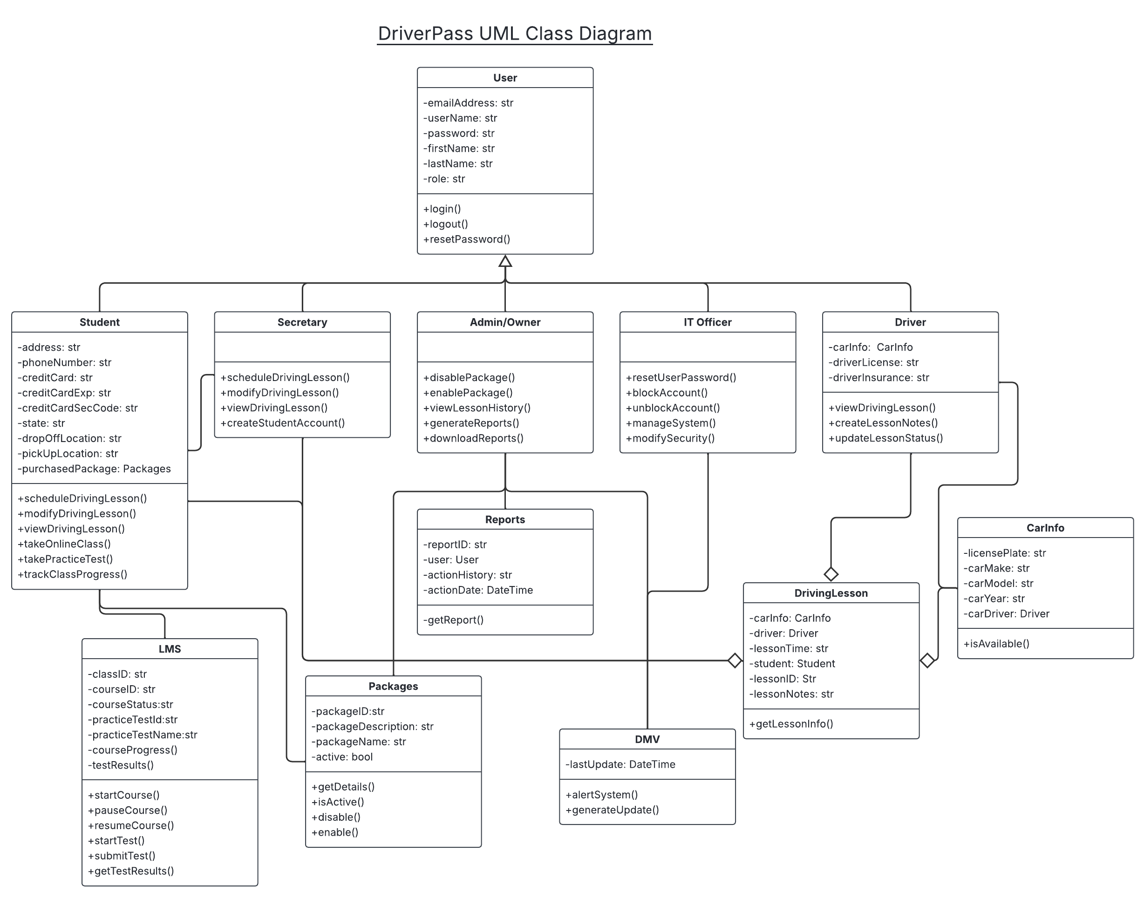

## Technical Requirements

* Hardware Requirements
  + System Host Hardware
    - Cloud-Based Hosting
    - Scalable infrastructure
  + Local Hardware
    - Desktops or laptops for the staff.
    - Tablet or phone for the driver’s notes.
  + Client Hardware
    - A device capable of accessing the internet.
* Software Requirements
  + System Host Software
    - Database
    - REST API
    - Payment Gateway
    - RBAC
    - Authentication and Authorization
    - Audit Log
    - Schedule Tracking/ Date and Time Tracking
  + Client Software
    - A compatible web browser
* Tool Requirements
  + Version Control
  + Version Testing
  + Performance Monitoring
  + Security Monitoring
  + Data Encryption
* Infrastructure
  + Cloud Based Platform for deployment
  + Storage solution
    - May be provided by Cloud Host
  + Automated backups
  + Robust Security